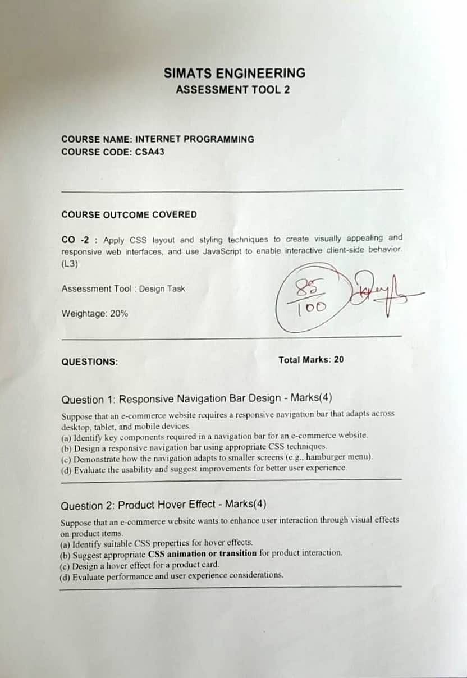
SIMATS

ENGINEERING
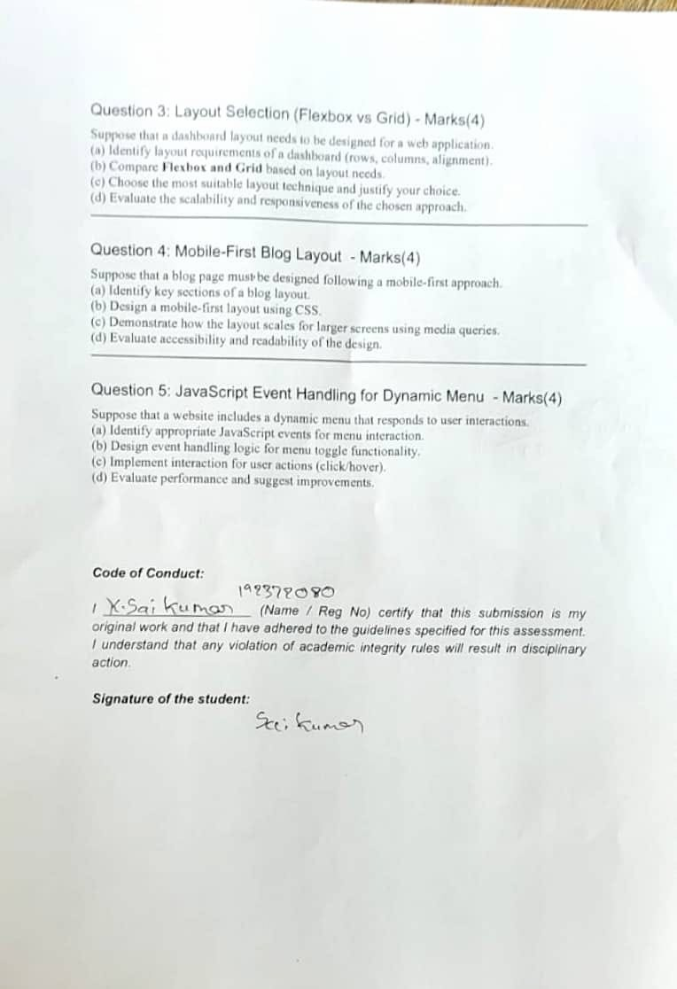

ASSESSMENT TOOL 2

COURSE NAME: INTERNET PROGRAMMING COURSE CODE: CSA43

COURSE OUTCOME COVERED

CO -2 : Apply CSS layout and styling techniques to create visually appealing and responsive web interfaces, and use JavaScript to enable interactive client-side behavior. (L3)

Assessment Tool : Design Task

Weightage: 20%

QUESTIONS: Total Marks: 20

Question 1: Responsive Navigation Bar Design - Marks(4)
Suppose that an e-commerce website requires a responsive navigation bar that adapts across desktop, tablet, and mobile devices.
(a) Identify key components required in a navigation bar for an e-commerce website.
(b) Design a responsive navigation bar using appropriate CSS techniques. (c)
Demonstrate how the navigation adapts to smaller screens (e.g., hamburger menu).
(d) Evaluate the usability and suggest improvements for better user experience.

Answer:
- Key components: brand logo, a compact set of top-level category links, a persistent search icon that expands into a search field, a wishlist/account/cart icon cluster, and (on small screens) a menu trigger that opens an off-canvas panel rather than a dropdown.
- Responsive nav using CSS Grid for the bar itself, so the logo, links and icon cluster stay aligned in three predictable zones:
<header class="navbar">
<a class="logo" href="/">ShopEase</a>
<ul class="nav-links">
<li><a href="#">Men</a></li>
<li><a href="#">Women</a></li>
<li><a href="#">Deals</a></li>
</ul>

<div class="nav-icons">
<button class="icon-btn" aria-label="Search">Search</button>
<button class="icon-btn" aria-label="Cart">Cart</button>
<button class="menu-btn" aria-label="Menu" aria-expanded="false">Menu</button>
</div>
</header>
.navbar {
display: grid;
grid-template-columns: auto 1fr auto; align-items: center;
padding: 0.75rem 1.5rem;
}
.menu-btn { display: none; }
- Adapting to smaller screens: instead of a simple dropdown, the menu becomes an off-canvas panel that slides in from the side, which scales better once the mobile menu also needs to hold search and account links.
@media (max-width: 767px) {
.nav-links { position: fixed; top: 0; right: -260px; width: 260px; height: 100vh; display: flex; flex-direction: column; transition: right 0.25s ease; }
.nav-links.open { right: 0; }
.menu-btn { display: inline-block; }
}
- Usability evaluation and improvements: an off-canvas panel avoids pushing page content down (unlike an inline dropdown) and scales to more links without feeling cramped. For further improvement, trap keyboard focus inside the panel while it's open, add a visible close (X) button, and dim the rest of the page with an overlay so users understand the panel is modal.

Question 2: Product Hover Effect - Marks(4)
Suppose that an e-commerce website wants to enhance user interaction through visual effects on product items.
- Identify suitable CSS properties for hover effects.
- Suggest appropriate CSS animation or transition for product interaction. (c) Design a hover effect for a product card.
(d) Evaluate performance and user experience considerations.

Answer:
- Suitable CSS properties: clip-path or transform: translateY on a pseudo-element overlay, plus opacity, give a richer 'reveal' effect than a plain shadow while still avoiding layout-affecting properties.
- Suggested effect: a details panel implemented as a ::after overlay that slides up from the bottom of the card on hover, revealing a 'View product' call to action.
- Hover effect for a product card:
.product-card { position: relative; overflow: hidden; }
.product-card::after {
content: 'View product'; position: absolute;
left: 0; right: 0; bottom: 0; padding: 0.75rem;
text-align: center;
background: rgba(0,0,0,0.75); color: #fff;
transform: translateY(100%);
transition: transform 0.25s ease;
}
.product-card:hover::after {

transform: translateY(0);
}
- Performance and UX considerations: because only transform and opacity change, the browser can composite the animation on the GPU without recalculating layout. The effect should be wrapped in @media (hover: hover) and (pointer: fine) so it only triggers on devices that support true hovering, and a prefers-reduced-motion query should shorten or disable the transition for users who have that OS setting enabled.

Question 3: Layout Selection (Flexbox vs Grid) - Marks(4)
Suppose that a dashboard layout needs to be designed for a web application. (a) Identify layout requirements of a dashboard (rows, columns, alignment). (b) Compare Flexbox and Grid based on layout needs.
- Choose the most suitable layout technique and justify your choice.
- Evaluate the scalability and responsiveness of the chosen approach.

Answer:
- Dashboard layout requirements: an overall page skeleton (topbar, sidebar, main area) plus, inside the main area, a collection of widget cards where each card itself needs internal one-directional alignment (icon, label and value in a row).
- Flexbox vs Grid: Grid is naturally suited to the page-level skeleton since it needs row and column control together; Flexbox is naturally suited to the contents inside each individual widget, which is really just a single row or column of items that should stay aligned and evenly spaced.
- Choice and justification: rather than picking one exclusively, the most idiomatic solution combines both - CSS Grid lays out the page skeleton and the widget collection, while Flexbox is used inside each widget card for the icon/label/value row. This matches each tool to the dimensionality of the problem it is actually solving.
.dashboard {
display: grid;
grid-template-columns: 220px 1fr; grid-template-rows: 60px 1fr;
}
.widgets {
display: grid;
grid-template-columns: repeat(auto-fit, minmax(200px, 1fr)); gap: 1rem;
}
.widget-card {
display: flex;
align-items: center; gap: 0.75rem;
}
- Scalability and responsiveness: the Grid skeleton adapts by collapsing the sidebar at narrow widths, the widget grid reflows automatically via auto-fit, and each widget's internal
Flexbox row keeps its content aligned regardless of the card's final width - future container queries could let each widget also restyle itself based on its own size rather than the viewport's.

Question 4: Mobile-First Blog Layout - Marks(4)
Suppose that a blog page must be designed following a mobile-first approach. (a) Identify key sections of a blog layout.
- Design a mobile-first layout using CSS.

- Demonstrate how the layout scales for larger screens using media queries. (d) Evaluate accessibility and readability of the design. Answer:
- Key sections: a hero/featured-post banner, category filter tags, the main article body with a readable type scale, a related-posts section, and a comments area, in addition to header and footer.
- Mobile-first CSS: base styles use a fluid type scale and a single-column vertical rhythm so the same markup reads well with no layout at all on the smallest screens.
:root { --step-0: 1rem; --step-1: 1.25rem; --step-2: 1.75rem; } body { font-size: var(--step-0); line-height: 1.6; }
h1 { font-size: var(--step-2); }
.article-body { max-width: 65ch; margin: 0 auto; }
- Scaling to larger screens: rather than a fixed sidebar breakpoint, the layout switches to a two-column CSS Grid with a sticky sidebar once there's enough width for both the text column and the sidebar to be comfortable.
@media (min-width: 900px) {
.page { display: grid; grid-template-columns: 2fr 1fr; gap: 2rem; align-items: start; }
.sidebar { position: sticky; top: 1rem; }
}
- Accessibility and readability evaluation: constraining .article-body to about 65 characters per line (max-width: 65ch) keeps paragraphs easy to track visually, the fluid type-scale variables make it simple to keep consistent proportions at every breakpoint, and using real heading levels (h1-h3) rather than styled <div>s lets screen-reader users navigate the article by heading.

Question 5: JavaScript Event Handling for Dynamic Menu - Marks(4)
Suppose that a website includes a dynamic menu that responds to user interactions. (a) Identify appropriate JavaScript events for menu interaction.
- Design event handling logic for menu toggle functionality.
- Implement interaction for user actions (click/hover).
- Evaluate performance and suggest improvements.

Answer:
- Appropriate events: pointerenter/pointerleave for hover-capable desktop pointers (with a short delay to avoid accidental triggers), and a plain click for touch devices, detected via matchMedia so touch users aren't forced to rely on hover.
- Event handling design: the menu is opened either by a deliberate hover 'intent' (a short timeout that only fires if the pointer stays over the trigger) or by a tap, and both paths converge on the same open()/close() functions so the visual and ARIA state can never fall out of sync.
- Implementation:
const trigger = document.querySelector('.menu-trigger'); const menu = document.querySelector('.dropdown-menu');
const isTouch = window.matchMedia('(pointer: coarse)').matches; let hoverTimer;
function openMenu() {
menu.classList.add('open');
trigger.setAttribute('aria-expanded', 'true');
}
function closeMenu() {

menu.classList.remove('open');
trigger.setAttribute('aria-expanded', 'false');
}
if (isTouch) {
trigger.addEventListener('click', (e) => { e.stopPropagation();
menu.classList.contains('open') ? closeMenu() : openMenu();
});
} else {
trigger.addEventListener('pointerenter', () => { hoverTimer = setTimeout(openMenu, 120);
});
trigger.addEventListener('pointerleave', () => { clearTimeout(hoverTimer);
closeMenu();
});
}
document.addEventListener('click', closeMenu);
- Performance evaluation and improvements: using pointer events instead of separate mouse/touch listeners avoids duplicate handling on hybrid devices, and the short hover-intent delay prevents the menu from flickering open on quick mouse passes. Listeners could be registered with { passive: true } where they don't call preventDefault, and the timer should be cleared on component teardown to avoid a dangling callback firing after the menu no longer exists.

Code of Conduct:

I (K.sai kumar/ 192372080) certify that this submission is my original work and that I have adhered to the guidelines specified for this assessment. I understand that any violation of academic integrity rules will result in disciplinary action.

Signature of the student: k.sai kumar

